EMPLOYMENT CONFIRMATION

Date: 2/14/2026
To whom it may concern,
This is to confirm that «Employee_name» has been employed with our company since «Start_date». The employee currently holds the position of «Position» under a «Type_of_contract» contract. As of January 31, 2026, the total period of employment amounts to «Employment_period_until_31012026» days. This confirmation is issued upon the employee’s request for official purposes.
Should you require any further information, please do not hesitate to contact us.
Sincerely,
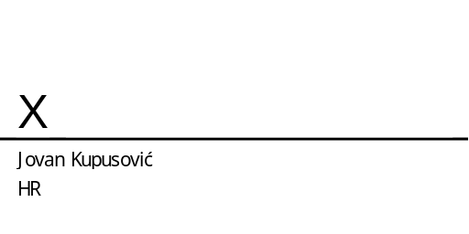
HR Department
JetBrains

